Name : Bankar Krushna Lahanubhau
MIS: 612303031
Batch – S2
Division 1 Computer

1st output Question

code:

#include <stdio.h>

int main() {
char inchar = 'A';
switch (inchar)
{
case 'A' :
printf ("choice A \n") ;
case 'B' :
printf ("choice B \n") ;
case 'C' :
printf ("choice C \n") ;
case 'D' :
printf ("choice D \n") ;
case 'E' :
printf ("choice E \n") ;
default:
printf ("No Choice") ;
}

return 0;
}

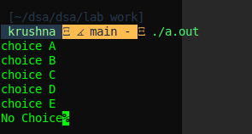
Screenshot

/*Write a program to add three floating point numbers. The result should contain only two digits after the decimal.*/

#include <stdio.h>

int main() {
float num1, num2, num3, sum;

printf("Enter three floating point numbers:\n");

scanf("%f %f %f", &num1, &num2, &num3);

sum = num1 + num2 + num3;

printf("The sum is: %.2f\n", sum);

return 0;
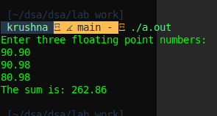
}

/*. Write a C program to check whether a year is leap year or not */
#include <stdio.h>

int is_leap_year(int year) {

if ((year % 4 == 0 && year % 100 != 0) || (year % 400 == 0)) {
return 1;
}
return 0;
}

int main() {
int year;

printf("Enter a year: ");
scanf("%d", &year);

if (is_leap_year(year)) {
printf("%d is a leap year.\n", year);
} else {
printf("%d is not a leap year.\n", year);
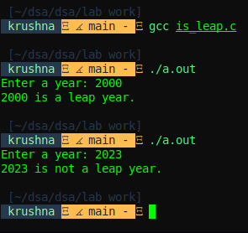
}

return 0;
}

OUTPUT

/*. Write a C program to input electricity unit charges and calculate total electricity bill according to the given condition: For first 50 units Rs. 0.50/unit For next 100 units Rs. 0.75/unit For next 100 units Rs. 1.20/unit For unit above 250 Rs. 1.50/unit An additional surcharge of 20% is added to the bill*/

#include <stdio.h>

float calculate_bill(float units) {

float bill = 0.0;
if (units <= 50) {
bill = units * 0.50;
}
else if (units <= 150) {
bill = 50 * 0.50 + (units - 50) * 0.75;
}
else if (units <= 250) {
bill = 50 * 0.50 + 100 * 0.75 + (units - 150) * 1.20;
}
else {
bill = 50 * 0.50 + 100 * 0.75 + 100 * 1.20 + (units - 250) * 1.50;
}

bill += bill * 0.20;

return bill;
}

int main() {
float units, total;

printf("Enter units: ");
scanf("%f", &units);

total = calculate_bill(units);
printf("total bill: Rs. %.2f\n", total);

return 0;
}
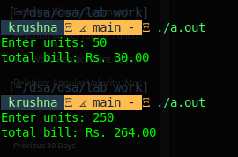
OUTPUT:

Code for First 4 questions if array assignment:

#include <stdio.h>
#define SIZE 10

int square_sum(int arr[]) {
int sum = 0;

for(int i = 0; i < SIZE; i++) {
sum += arr[i] * arr[i];
}

return sum;
}

void diplay_reverse_array(int arr[]) {
for(int i = SIZE - 1; i >= 0; i--) {
printf("%d ", arr[i]);
}

printf("\n");

return;
}

void diplay_array_triangular(int arr[]) {
for(int i = 0; i < SIZE; i++) {

for(int j = 0; j < i + 1; j++) {
printf("%d ", arr[j]);
}

printf("\n");

}

return;
}

int main() {
int arr[SIZE];
printf("Enter array elements: \n");
//loop get array elements;
for(int i = 0; i < SIZE; i++) {
scanf("%d", &arr[i]);
}

int sum = square_sum(arr);
printf("%d is the sum of square of element of given array\n", square_sum(arr));

printf("Reverse array is: \n");

diplay_reverse_array(arr);

printf("Array in Triangular form: \n");

diplay_array_triangular(arr);

return 0;
}
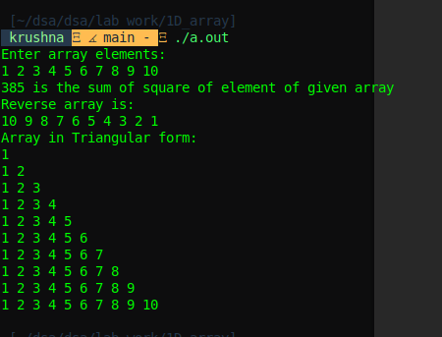
OUTPUT:

Code for Left and right shift of an array question:
#include <stdio.h>
#define SIZE 10

void leftshift(int arr[], int n) {

int temp[SIZE];

for(int i = 0; i < SIZE; i++) {

int j;
if(i + n >= SIZE) {
j = (i + n) % SIZE;
temp[j] = arr[i];
}
else{
temp[i + n] = arr[i];
}
}

for(int i = 0; i < SIZE; i++) {

arr[i] = temp[i];

}

return;
}

void printArray(int arr[]) {

for(int i = 0; i < SIZE; i++) {
printf("%d ", arr[i]);
}

printf("\n");
return;
}

void rightshift(int arr[], int n) {

int count = 0;
while(count < n) {

int last_element = arr[SIZE - 1], i;

for(i = SIZE - 1; i > 0; i--) {
arr[i] = arr[i - 1];
}

arr[0] = last_element;
count++;

}

return;
}
int main() {

int arr[SIZE];
printf("Enter array elements(10): \n");
for(int i = 0; i < SIZE; i++){
scanf("%d", &arr[i]);
}

int n;
printf("Enter n to shift array to left or right by n locations: \n");
scanf("%d", &n);
leftshift(arr, n);
printf("Array before left shift: \n");
printArray(arr);
printf("Array after left shift: \n");
printArray(arr);
printf("Array before right shift: \n");
printArray(arr);
printf("Array after right shift: \n");
rightshift(arr, n);
printArray(arr);
return 0;
}
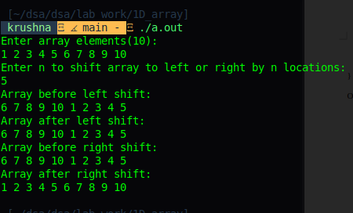
OUTPUT:

code to remove duplicates:
#include <stdio.h>

void left_shift(int arr[], int n, int i) {
for(int j = i; j < n - 1; j++) {
arr[j] = arr[j + 1];
}
return;
}

void remove_duplicates(int arr[], int *n) {
int len = *n;
for(int i = 0; i < len; i++) {
int ele = arr[i];
for(int j = i + 1; j < len; j++) {
if(arr[j] == ele) {
left_shift(arr, len, i);
len--;
j--;
}
}

}
*n = len;
return;
}

void printArray(int arr[], int n) {

for(int i = 0; i < n; i++) {
printf("%d ", arr[i]);
}

printf("\n");
return;
}

int main() {
int n;
printf("Enter size of array\n");
scanf("%d", &n);
int arr[n];
printf("Enter array elements: \n");

for(int i = 0; i < n; i++){
scanf("%d", &arr[i]);
}

remove_duplicates(arr, &n);
printf("Array after removing duplicates\n");
printArray(arr, n);
return 0;
}

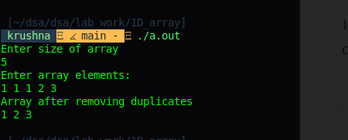
OUTPUT:

code about use of rand() function

#include<stdio.h>
#include<stdlib.h>
int main() {
int c, n;
printf("Ten random numbers in [50,100]\n");
for (c = 1; c <= 10; c++) {
n = rand() % 51 + 50; /*rand() % 51 returns numbers from 0 to 50 adding 50 makes it to 50 to 100 */
printf("%d\n", n);
}
return 0;
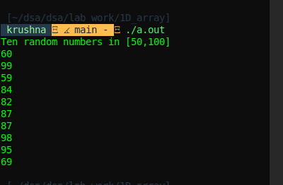
}

OUTPUT:

/*Take 20 integer inputs from user and print the following: number of positive numbers number of negative numbers number of odd numbers number of even numbers number of 0*/

code:
#include <stdio.h>

#define SIZE 20

int count_negative_no(int arr[]){
int count = 0;
for(int i = 0; i < SIZE; i++){
if(arr[i] < 0) {
count++;
}
}
return count;
}

int count_positive_no(int arr[]){
int count = 0;
for(int i = 0; i < SIZE; i++){
if(arr[i] > 0) {
count++;
}
}
return count;
}

int count_odd_no(int arr[]){
int count = 0;
for(int i = 0; i < SIZE; i++){
if((arr[i] % 2) != 0) {
count++;
}
}
return count;
}

int count_even_no(int arr[]){
int count = 0;
for(int i = 0; i < SIZE; i++){
if((arr[i] % 2) == 0) {
count++;
}
}
return count;
}

int count_zeros(int arr[]){
int count = 0;
for(int i = 0; i < SIZE; i++){
if(arr[i] == 0) {
count++;
}
}
return count;
}
int main() {

printf("Enter 20 numbers with spaces: \n");
int arr[SIZE];

for(int i = 0; i < SIZE; i++){
scanf("%d", &arr[i]);
}

printf("No of positive numbers: %d\n", count_positive_no(arr));
printf("No of negative numbers: %d\n", count_negative_no(arr));
printf("No of odd numbers: %d\n", count_odd_no(arr));
printf("No of even numbers: %d\n", count_even_no(arr));
printf("No of 0's: %d\n", count_zeros(arr));

return 0;
}
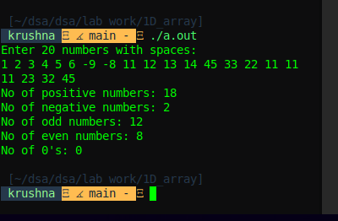
OUTPUT:

array palindrom and reverse array question code:
#include <stdio.h>

int check_palindrome(int arr[], int n) {

int i, j;
i = 0;
j = n - 1;

while(i < j) {
if(arr[i] != arr[j]) {
return 0;
}
i++;
j--;
}

return 1;
}

void swap(int *a, int *b) {
int temp = *a;
*a = *b;
*b = temp;
return;
}

void reverse_array(int arr[], int n) {

int i, j;
i = 0;
j = n - 1;

while(i < j) {
swap(&arr[i], &arr[j]);
i++;
j--;
}

return;
}

void printArray(int arr[], int n) {

for(int i = 0; i < n; i++) {
printf("%d ", arr[i]);
}

printf("\n");

return;
}

int main() {

printf("Enter array size: \n");
int n;
scanf("%d", &n);
int arr[n];
printf("Enter array elements: \n");

for(int i = 0; i < n; i++){
scanf("%d", &arr[i]);
}

if(check_palindrome(arr, n)){
printf("Given array is Palindrome\n");
}
else {
printf("Given array is not Palindrome\n");
}
reverse_array(arr, n);
printArray(arr, n);
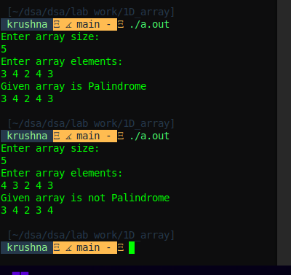
return 0;
}

OUTPUT:

/*C program to find nearest lesser and greater element in an array*/
#include <stdio.h>
#include <limits.h>

int nearest_lesser(int arr[], int n, int key) {
int nearest = INT_MIN;
for(int i = 0; i < n; i++) {
if(arr[i] < key && arr[i] > nearest) {
nearest = arr[i];
}
}
return nearest;
}

int nearest_greater(int arr[], int n, int key) {
int nearest = INT_MAX;
for(int i = 0; i < n; i++) {
if(arr[i] > key && arr[i] < nearest) {
nearest = arr[i];
}
}
return nearest;
}
int main() {
int n, key;
printf("Enter size of an array: \n");
scanf("%d", &n);
int arr[n];

printf("Enter contents of an array: \n");
for(int i = 0; i < n; i++) {
scanf("%d", &arr[i]);
}
printf("Enter number to which nearest lesser and greater number are required: \n");
scanf("%d", &key);
printf("Nearest lesser number is: %d \n", nearest_lesser(arr, n, key));
printf("Nearest greater number is: %d \n", nearest_greater(arr, n, key));

return 0;
}
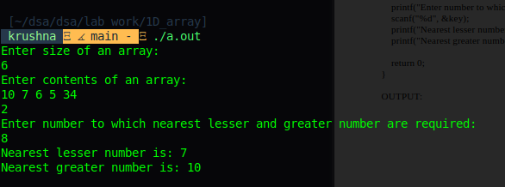
OUTPUT:
/*. You have 2 arrays of size 5 each having elements in sorted order. Create a new array of 10 having elements of the both the arrays in sorted order. Eg: int A = { 45, 50 70, 85, 90}; int B = { 30, 40, 60, 75, 80}; int C[10] After the execution of code array C should have following elements:*/

code:
#include <stdio.h>

void merge(int a[], int b[], int c[]) {
int i = 0, j = 0, k = 0;

while (i < 5 && j < 5) {
if (a[i] <= b[j]) {
c[k++] = a[i++];
} else {
c[k++] = b[j++];
}
}

while (i < 5) {
c[k++] = a[i++];
}

while (j < 5) {
c[k++] = b[j++];
}

return;
}

int main() {

int a[] = {45, 50, 70, 85, 90};
int b[] = {30, 40, 60, 75, 80};
int c[10];

merge(a, b, c);

printf("Content of merged array are: \n");

for(int i = 0; i < 10; i++) {
printf("%d ", c[i]);
}
printf("\n");

return 0;
}

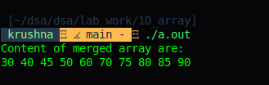
output:

/*Populate an array of size 100 with values generated randomly between 1 to 1000. Copy all the numbers divisible by 8 or 15 to a new array. Display both arrays.*/
#include <stdio.h>
#include <stdlib.h>

#define SIZE 100

int main() {
int arr[SIZE], ans[SIZE], j;

for(int i = 0; i < SIZE; i++) {
arr[i] = rand() % 1000;
}

j = 0;

for(int i = 0; i < SIZE; i++) {
if(arr[i] % 8 == 0 || arr[i] % 15 == 0) {
ans[j++] = arr[i];
}
}

printf("Contents of original array: \n");
for(int i = 0; i < SIZE; i++) {
printf("%d ", arr[i]);
}
printf("\n");
printf("Contents of array having numbers divisible by 8 and 15 \n");
for(int i = 0; i < j; i++) {
printf("%d ", ans[i]);
}
printf("\n");

return 0;
}
OUTPUT

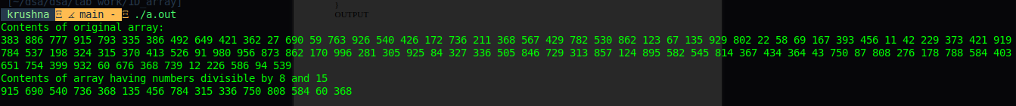
krushna   main -  ./a.out
Contents of original array:
383 886 777 915 793 335 386 492 649 421 362 27 690 59 763 926 540 426 172 736 211 368 567 429 782 530 862 123 67 135 929 802 22 58 69 167 393 456 11 42 229 373 421 919 784 537 198 324 315 370 413 526 91 980 956 873 862 170 996 281 305 925 84 327 336 505 846 729 313 857 124 895 582 545 814 367 434 364 43 750 87 808 276 178 788 584 403 651 754 399 932 60 676 368 739 12 226 586 94 539
Contents of array having numbers divisible by 8 and 15
915 690 540 736 368 135 456 784 315 336 750 808 584 60 368
Second Largest Element in array:

code:

#include <stdio.h>
#include <limits.h>

int second_largest(int arr[], int n) {

int max1 = INT_MIN, max2 = INT_MIN;

for(int i = 0; i < n; i++) {
if(arr[i] > max1) {
max2 = max1;
max1 = arr[i];
} else if(arr[i] > max2 && arr[i] < max1) {
max2 = arr[i];
}
}
return max2;

}

int main() {

int n;
printf("Enter size of array: ");
scanf("%d", &n);

int arr[n];

printf("Enter array elements: \n");
for(int i = 0; i < n; i++) {
scanf("%d", &arr[i]);
}

printf("Second largest number in the array is: %d\n", second_largest(arr, n));

return 0;
}
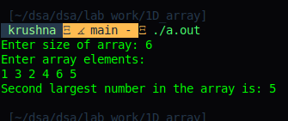
OUTPUT:

STRUCTURES ASSIGNMENT

Code for first 2 questions

#include <stdio.h>
#include <stdlib.h>
#include <string.h>

#define MAX_SIZE 20
typedef struct name{
char first_name[MAX_SIZE];
char middle_name[MAX_SIZE];
char last_name[MAX_SIZE];
}Name;

typedef struct date{
short int day;
short int month;
int year;
}Date;

typedef struct marks{
double english;
double mathematics;
double computer_science;
}Marks;

typedef struct student{
int roll_no;
Name name;
char gender[6];
Date date;
Marks marks;
}Student;

void calculate_aggregate(struct student students[], double aggregate[], int n) {

double sum = 0;

for(int i = 0; i < n; i++) {
sum = students[i].marks.english + students[i].marks.mathematics + students[i].marks.computer_science;
aggregate[i] = sum / 3;
}

return;

}

void display_student_details(struct student students[], int index) {
printf("Name: %s %s %s\n", students[index].name.first_name, students[index].name.middle_name, students[index].name.last_name);
printf("Roll No : %d\n", students[index].roll_no);
printf("Gender: %s\n", students[index].gender);
printf("Date of Birth: %d - %d - %d\n", students[index].date.day, students[index].date.month, students[index].date.year);
printf("Marks:\n\tEnglish-> %.2f\n\tMathematics-> %.2f\n\tComputer Science-> %.2f\n", students[index].marks.english, students[index].marks.mathematics, students[index].marks.computer_science);
return;
}

void search_student_by_name(Student students[], char first_name[], char middle_name[], char last_name[], int n) {

int found = 0;

for(int i = 0; i < n; i++) {

if(strcmp(first_name, students[i].name.first_name) == 0 && strcmp(middle_name, students[i].name.middle_name) == 0 && strcmp(last_name, students[i].name.last_name) == 0 ){
found = 1;
display_student_details(students, i);
break;
}

}

if(!found) {
printf("Not found!");
}

return;
}

void print_average_marks(Student students[], int n) {

double sum = 0;

for(int i = 0; i < n; i++) {
sum = students[i].marks.english + students[i].marks.mathematics + students[i].marks.computer_science;
printf("Name: %s %s %s\t", students[i].name.first_name, students[i].name.middle_name, students[i].name.last_name);
printf("Average marks are: %.2f \n", sum / 3.0);
}

return;
}

int main() {
//Sample of 10 students
Student students[10] = {
{101, {"John", "Alexander", "Doe"}, "Male", {15, 8, 2004}, {85.5, 92.0, 89.75}},
{102, {"Jane", "Elizabeth", "Smith"}, "Female", {22, 11, 2003}, {90.0, 95.0, 88.5}},
{103, {"Michael", "James", "Johnson"}, "Male", {5, 3, 2005}, {78.25, 84.5, 80.0}},
{104, {"Emily", "Grace", "Williams"}, "Female", {19, 7, 2004}, {92.0, 89.75, 91.5}},
{105, {"David", "Lee", "Brown"}, "Male", {12, 9, 2003}, {30, 44.5, 13.25}},
{106, {"Emma", "Rose", "Jones"}, "Female", {30, 6, 2004}, {84.5, 87.0, 90.0}},
{107, {"Daniel", "Andrew", "Garcia"}, "Male", {8, 1, 2005}, {33.75, 23.5, 32.0}},
{108, {"Olivia", "Marie", "Martinez"}, "Female", {14, 12, 2004}, {91.0, 93.5, 89.25}},
{109, {"Sophia", "Claire", "Rodriguez"}, "Female", {25, 4, 2003}, {89.5, 94.0, 87.75}},
{110, {"James", "William", "Wilson"}, "Male", {18, 10, 2004}, {86.5, 90.0, 88.0}}
};

double aggregate[10], n = 10;
//Function to calculate aggreagate marks of all the students and stores in tbe array aggregate
calculate_aggregate(students, aggregate, n);

printf("Names of students who secured less than 40 percent aggregate marks\n");
printf("\n");

for(int i = 0; i < n; i++) {
if(aggregate[i] < 40) {
printf("%s %s %s %.2f\n", students[i].name.first_name, students[i].name.middle_name, students[i].name.last_name, aggregate[i]);
}
}

printf("\n");

char first_name[MAX_SIZE], middle_name[MAX_SIZE], last_name[MAX_SIZE];

printf("Enter first name: \n");
scanf("%[^\n]", first_name);
printf("Enter middle_name: \n");
scanf(" %[^\n]", middle_name);
printf("Enter last name: \n");
scanf(" %[^\n]", last_name);

//Function to search student by name
search_student_by_name(students, first_name, middle_name, last_name, n);
//Function to print average marks of all the students
print_average_marks(students, n);

return 0;
}

OUTPUT:

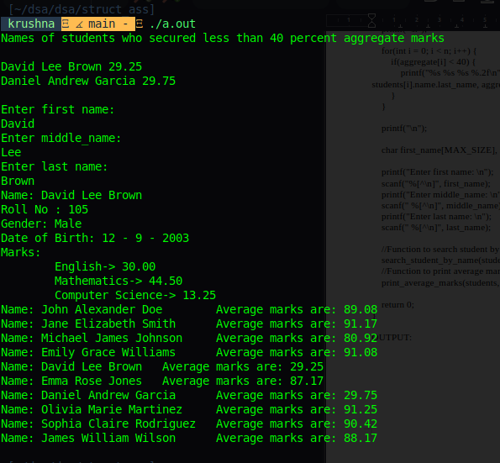

/*3 Write a program to define a structure for a hotel that has members— name, address, grade, number of rooms, and room charges. Write a function to print the names of hotels in a particular grade. Also write a function to print names of hotels that have room charges less than the specified value.*/

#include <stdio.h>

typedef struct hotel{
char name[30];
char address[100];
char grade;
int num_rooms;
int room_charges;
}hotel;

void print_hotel_with_grade(hotel hotels[], char grade) {
for(int i = 0; i < 10; i++) {
if(hotels[i].grade == grade) {
printf("%s\n", hotels[i].name);
}
}
return;
}

void hotels_with_less_charges(hotel hotels[], int charges) {
for(int i = 0; i < 10; i++) {
if(hotels[i].room_charges < charges) {
printf("%s\n", hotels[i].name);
}
}
return;
}

int main() {

/* sample of 10 hotels */
int charges;
hotel hotels[10] = {
{"Grand Plaza", "123 Main St, Cityville", 'A', 100, 1500},
{"Ocean View", "456 Beach Rd, Seaside", 'B', 80, 1200},
{"Mountain Retreat", "789 Hilltop Dr, Highland", 'A', 60, 180},
{"Urban Inn", "101 Downtown Ave, Metropolis", 'C', 120, 100},
{"Country Lodge", "202 Country Ln, Farmington", 'B', 40, 90},
{"Royal Suites", "303 Luxury Blvd, Elegance", 'A', 50, 200},
{"Sunset Hotel", "404 Sunset Blvd, Bayside", 'B', 70, 1100},
{"Historic Hotel", "505 Heritage St, Oldtown", 'C', 90, 130},
{"Vista Hotel", "606 Viewpoint Dr, Skyline", 'B', 85, 140},
{"Comfort Inn", "707 Cozy Ct, Suburbia", 'C', 110, 95}
};

char grade;
printf("Enter grade to get hotel names: \n");
grade = getchar();
print_hotel_with_grade(hotels, grade);
printf("Enter room charges: \n");
scanf("%d", &charges);
printf("Following hotels have room charges less than %d\n", charges);
hotels_with_less_charges(hotels, charges);
return 0;
}

OUTPUT:
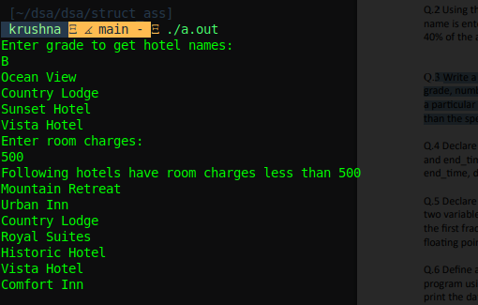

/*4 Declare a structure time that has three fields—hr, min, sec. Create two variables start_time and end_time. Input their values from the user. Then while start_time does not reach the end_time, display GOOD DAY on the screen.*/

#include <stdio.h>

typedef struct time {
int hr;
int min;
int sec;
} time;

void increment_time(time *t) {
t->sec++;

if (t->sec == 60) {
t->sec = 0;
t->min++;
}

if (t->min == 60) {
t->min = 0;
t->hr++;
}

return;
}

// Function to compare two times
int is_time_equal(time t1, time t2) {
return t1.hr == t2.hr && t1.min == t2.min && t1.sec == t2.sec;
}

int main() {
time start_time, end_time;

printf("Enter start time (hr min sec): ");
scanf("%d %d %d", &start_time.hr, &start_time.min, &start_time.sec);

printf("Enter end time (hr min sec): ");
scanf("%d %d %d", &end_time.hr, &end_time.min, &end_time.sec);

while (!is_time_equal(start_time, end_time)) {
printf("GOOD DAY\n");
increment_time(&start_time);
}

return 0;
}
OUTPUT

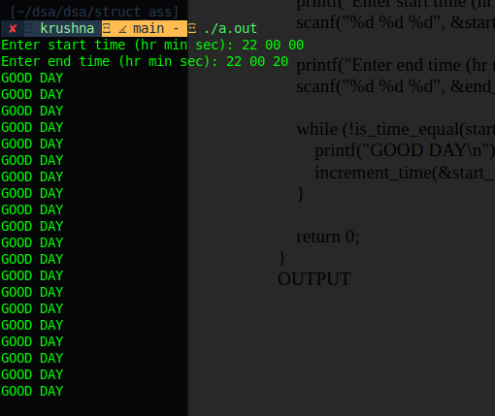

/*5 Declare a structure fraction that has two fields— numerator and denominator. Create two variables and compare them using function. Return 0 if the two fractions are equal, –1 if the first fraction is less than the second and 1 otherwise. You may convert a fraction into a floating point number for your convenience.*/
\#include <stdio.h>

typedef struct fraction {

int numerator;
int denominator;

}fraction;

int compare_fraction(fraction f1, fraction f2) {

double d1, d2;
d1 = f1.numerator / f1.denominator;
d2 = f2.numerator / f2.denominator;

if(d1 == d2) {
return 0;
}
else if(d1 < d2) {
return -1;
}

return 1;
}

int main() {

fraction f1, f2;

printf("Enter numerator and denominator of fraction 1: ");
scanf("%d%d", &f1.numerator, &f1.denominator);
printf("Enter numerator and denominator of fraction 2: ");
scanf("%d%d", &f2.numerator, &f2.denominator);
printf("Function returns: %d\n", compare_fraction(f1, f2));

return 0;
}

OUTPUT
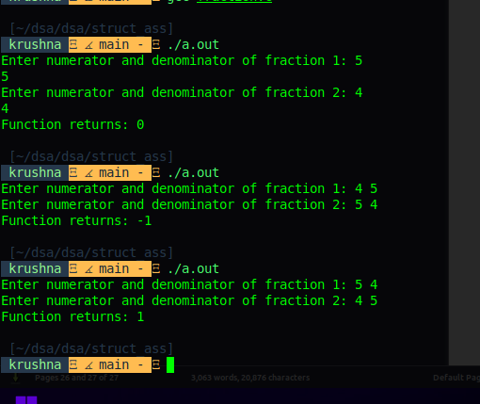
O

/*Define a structure date containing three integers— day, month, and year. Write a program using functions to read data, to validate the date entered by the user and then print the date on the screen. For example, if you enter 29/2/2010 then that is an invalid date as 2010 is not a leap year. Similarly 31/6/2007 is invalid as June does not have 31 days.*/

#include <stdio.h>

typedef struct date{

int day;
int month;
int year;

}date;

/* A leap year is divisible by 4 but if divisible by 100, it should also be divisible by 400. */
int is_leapyear(int year) {

if (year % 4 == 0) {
if (year % 100 == 0) {
if (year % 400 == 0) {
return 1;
} else {
return 0;
}
}
else {
return 1;
}
}

return 0;
}

int validate_date(date d) {

switch(d.month) {
case 01:
if(d.day <= 31) {
return 1;
}
else {
return 0;
}
break;
case 02:
if(is_leapyear(d.year)) {
if(d.day <= 29) {
return 1;
}
else {
return 0;
}
}
else {
if(d.day <= 28) {
return 1;
}
else {
return 0;
}
}
break;
case 03:
if(d.day <= 31) {
return 1;
}
else {
return 0;
}
break;
case 04:
if(d.day <= 30) {
return 1;
}
else {
return 0;
}
break;
case 05:
if(d.day <= 31) {
return 1;
}
else {
return 0;
}
break;
case 06:
if(d.day <= 30) {
return 1;
}
else {
return 0;
}
break;
case 07:
if(d.day <= 31) {
return 1;
}
else {
return 0;
}
break;
case 8:
if(d.day <= 31) {
return 1;
}
else {
return 0;
}
break;
case 9:
if(d.day <= 30) {
return 1;
}
else {
return 0;
}
break;
case 10:
if(d.day <= 31) {
return 1;
}
else {
return 0;
}
break;
case 11:
if(d.day <= 30) {
return 1;
}
else {
return 0;
}
break;
case 12:
if(d.day <= 31) {
return 1;
}
else {
return 0;
}
break;
default:
return 0;
}

return 0;
}

int main() {

date d1;
printf("Enter date (dd mm yyyy): ");
scanf("%d%d%d", &d1.day, &d1.month, &d1.year);

if(validate_date(d1)) {
printf("Date is valid!\n");
}
else {
printf("Date is invalid!\n");
}

return 0;
}

OUTPUT:

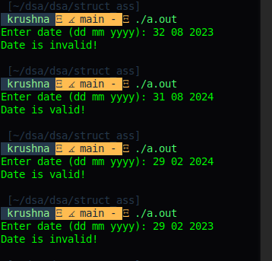

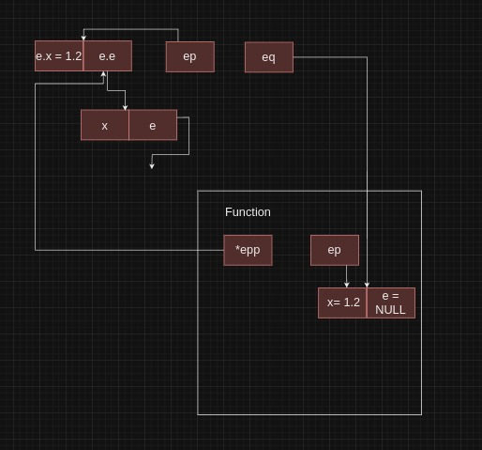
POINTERS ASSIGNMENT
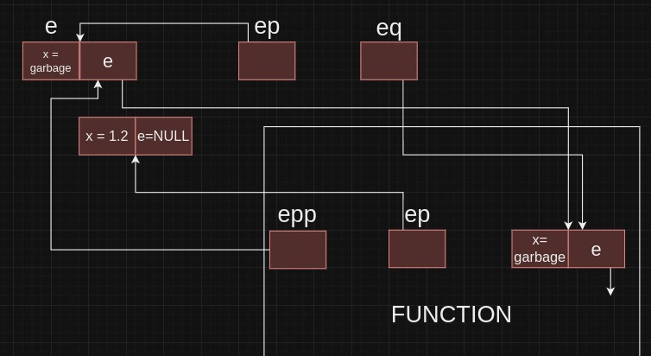

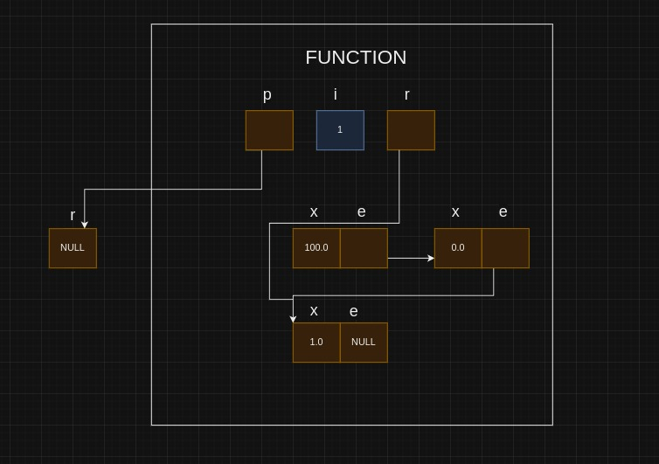
Polynomials Assignent

main.c

#include <stdio.h>
#include "poly.h"

int main() {

poly p, q, addition, subtraction;
int size1, size2, coef, exp, max_exp;

printf("Enter size of Polynomial 1: \n");
scanf("%d", &size1);
printf("Enter size of Polynomial 2: \n");
scanf("%d", &size2);
init_poly(&p, size1);
init_poly(&q, size2);

printf("Enter coef and exp of polynomial 1: (x^2+x^1+1 --> 1 2 1 1 1 0): \n");

for(int i = 0; i < size1; i++) {
scanf("%d%d", &coef, &exp);
append(&p, coef, exp);
}

printf("Enter coef and exp of polynomial 1: (x^2+x^1+1 --> 1 2 1 1 1 0): \n");

for(int i = 0; i < size2; i++) {
scanf("%d%d", &coef, &exp);
append(&q, coef, exp);
}

max_exp = max(p.P[0].exp, q.P[0].exp);
init_poly(&addition, max_exp+1);
init_poly(&subtraction, max_exp+1);
display(p);
display(q);
add_poly(&p, &q, &addition);
printf("Addition of the two polynomial is: \n");
display(addition);
sub_poly(&p, &q, &subtraction);
printf("Subtraction of the two polynomial is: \n");
display(subtraction);

/* sort_according_to_exp(&p);
display(p);
display(q);*/
return 0;

}

poly.c

#include <stdio.h>
#include <stdlib.h>
#include "poly.h"

void init_poly(poly *p, int size) {

p->P = (term *)malloc(sizeof(term) * size);
p->size = size;
p->len = 0;

return;

}

void append(poly *p, int coef, int exp) {

if(p->len < p->size) {
int i = p->len;
p->P[i].coef = coef;
p->P[i].exp = exp;
p->len++;
}

return;

}

void display(poly p) {
int i;
printf("\n");
for(i = 0; i < p.len - 1; i++) {
printf("(%d)x^%d + ", p.P[i].coef, p.P[i].exp);
}

printf("(%d)x^%d\n\n", p.P[i].coef, p.P[i].exp);
return;
}

void sort_according_to_exp(poly *p) {
//Using insertion sort
int i = 1, n = p->len;

while(i < n) {

int ele, j, coef;
ele = p->P[i].exp;
j = i - 1;
coef = p->P[i].coef;

while(j >= 0 && ele > p->P[j].exp) {
p->P[j + 1].exp = p->P[j].exp;
p->P[j + 1].coef = p->P[j].coef;
j = j - 1;
}

p->P[j + 1].exp = ele;
p->P[j + 1].coef = coef;
i++;

}

return;
}
//These function fails if user inputs same exponent term multiple times
poly convert_to_standard_form(poly *p, int max_exp) {

int i = 0;
poly standard_form;
int size = max_exp + 1;
init_poly(&standard_form, size);
while(max_exp >= 0) {

if(p->P[i].exp == max_exp && i < p->len) {
append(&standard_form, p->P[i].coef, max_exp);
i++;
}
else {
append(&standard_form, 0, max_exp);
}

max_exp--;
}
return standard_form;

}

int max(int a, int b) {

if(a > b) {
return a;
}

return b;
}

void add_poly(poly *p, poly *q, poly *result) {

sort_according_to_exp(p);
sort_according_to_exp(q);
int max_exp = max(p->P[0].exp, q->P[0].exp);
poly standard_form_q, standard_form_p;
init_poly(&standard_form_p, max_exp + 1);
standard_form_p = convert_to_standard_form(p, max_exp);
standard_form_q = convert_to_standard_form(q, max_exp);

for(int i = 0; i <= max_exp; i++) {
append(result, standard_form_p.P[i].coef + standard_form_q.P[i].coef, standard_form_q.P[i].exp);
}
return;

}

void sub_poly(poly *p, poly *q, poly *result) {

sort_according_to_exp(p);
sort_according_to_exp(q);
int max_exp = max(p->P[0].exp, q->P[0].exp);
poly standard_form_q, standard_form_p;
init_poly(&standard_form_p, max_exp + 1);
standard_form_p = convert_to_standard_form(p, max_exp);
standard_form_q = convert_to_standard_form(q, max_exp);

for(int i = 0; i <= max_exp; i++) {
append(result, standard_form_p.P[i].coef - standard_form_q.P[i].coef, standard_form_q.P[i].exp);
}
return;

}

poly.h

typedef struct term{
int coef; //Coefficient
int exp; //exponent
}term;

typedef struct poly {
term *P;
int size;
int len;
}poly;

void init_poly(poly *p, int size);
void append(poly *p, int coef, int exp);
void display(poly p);
void add_poly(poly *p, poly *q, poly *result);
void sub_poly(poly *p, poly *q, poly *result);
int max(int a, int b);
void sort_according_to_exp(poly *p);

output:

